**Savitzky-Golay**

**Determining the optimal window size and polynomial order for the Savitzky-Golay filter.**

|  |  |  |  |
| --- | --- | --- | --- |
| Window Size | Polyorder = 1 | Polyorder = 3 | Polyorder = 5 |
| 43 | 0.9899 | 0.9685 | 0.9398 |
| 63 | 0.9948 | 0.9860 | 0.9687 |
| 83 | 0.9966 | 0.9920 | 0.9824 |
| 93 | 0.9974 | 0.9936 | 0.9860 |
| 103 | 0.9978 | 0.9948 | 0.9884 |
| 123 | 0.9977 | 0.9964 | 0.9927 |
| 143 | 0.9980 | 0.9977 | 0.9945 |
| 163 | 0.9981 | 0.9982 | 0.9959 |
| 203 | 0.9985 | 0.9987 | 0.9975 |

**Table:** Altering window size and polynomial order with KNN accuracy to find the optimal values.

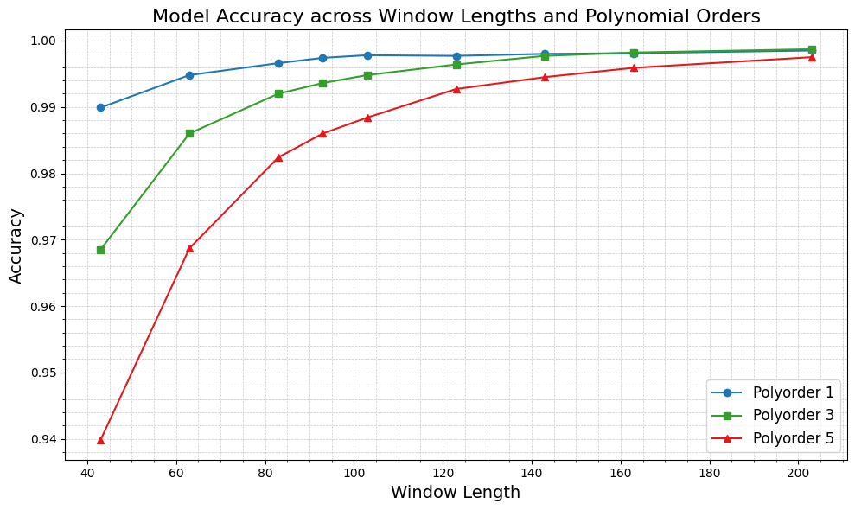

**Figure:** KNN model accuracy across different window lengths and polynomial orders

**Savitzky-Golay**

Polyorder = 3, Window Size = 203

Alert Data

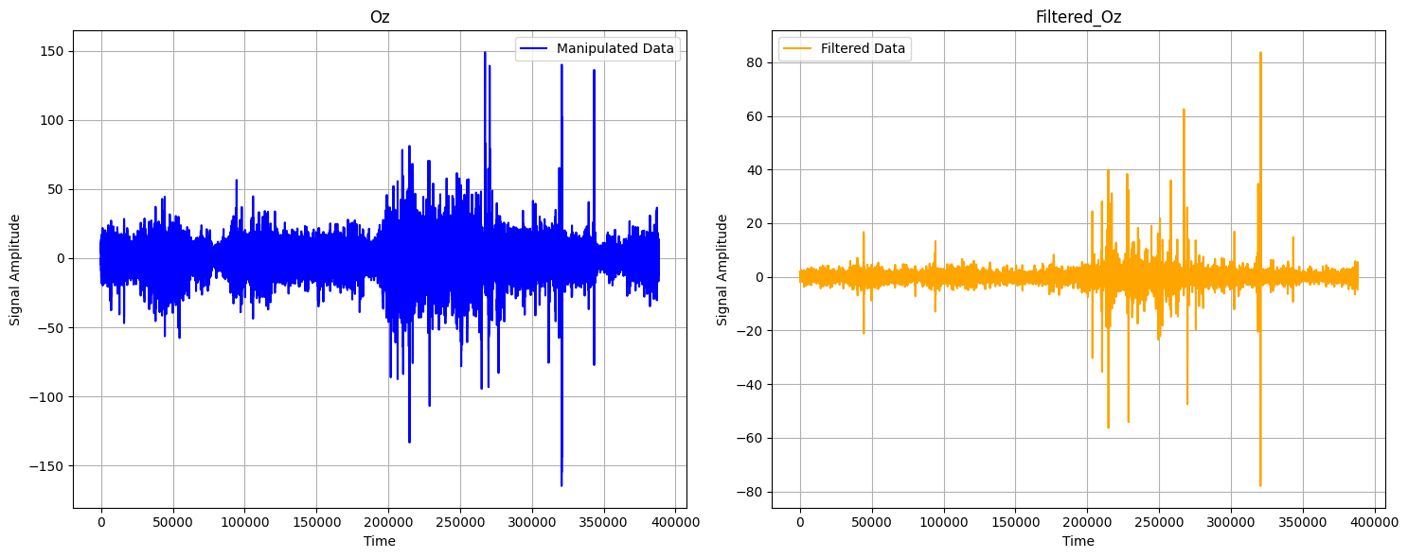

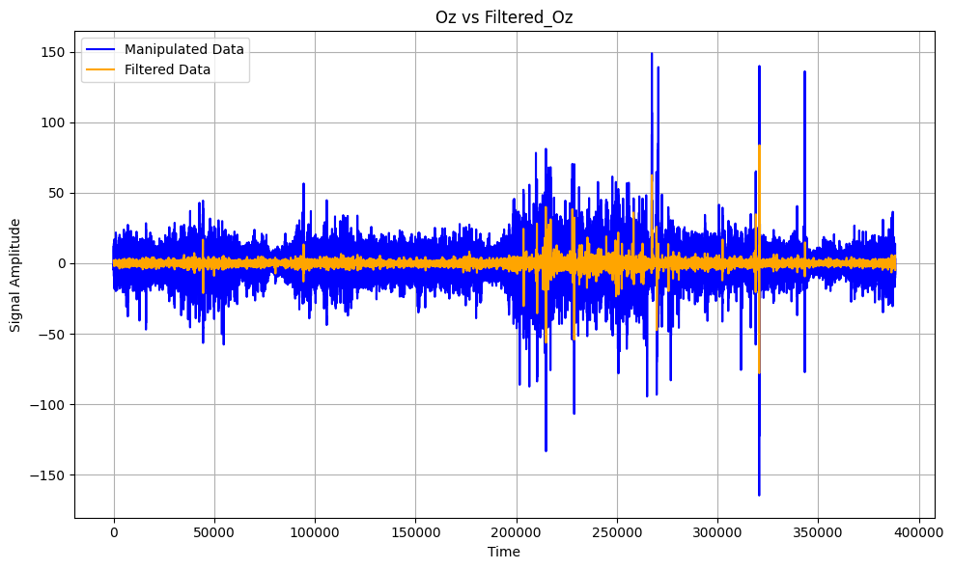

**Figure:** Alert Data Visualization of unfiltered EEG signals (Oz) vs. filtered Oz signals.

Drowsy Data

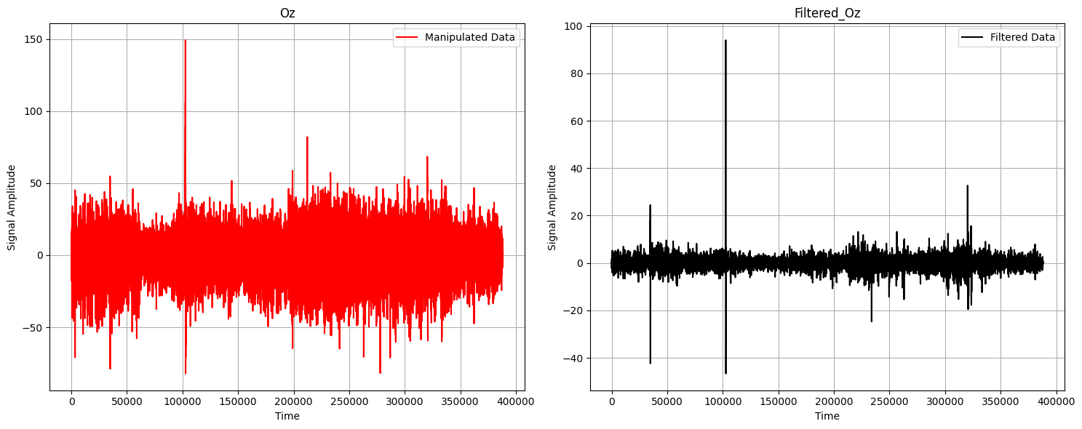

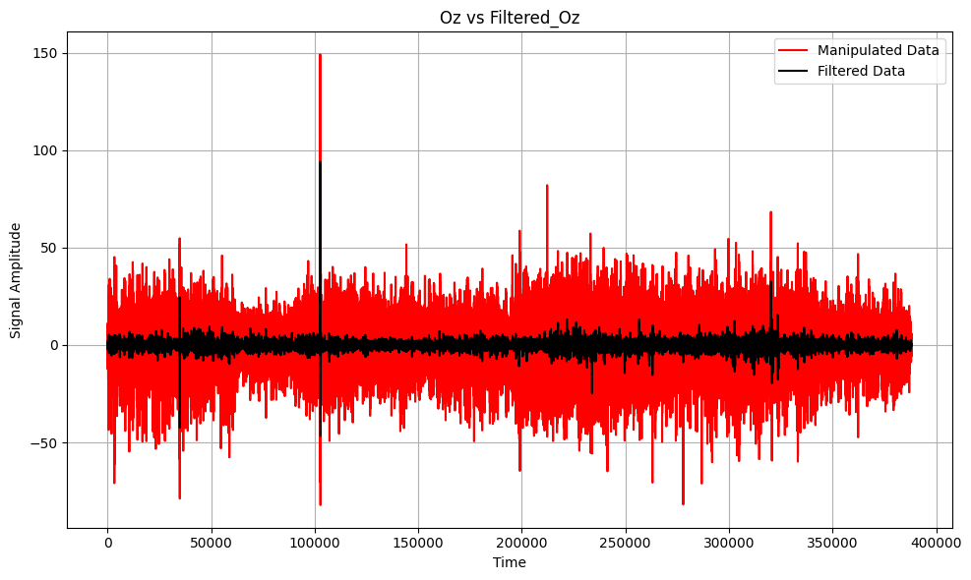

**Figure:** Drowsy Data visualization of unfiltered EEG signals (Oz) vs. filtered Oz signals.

**Machine Learning Evaluation with Savitzky-Golay Filter** (Polyorder: 3, Window Size: 203)

|  |  |  |  |  |  |  |
| --- | --- | --- | --- | --- | --- | --- |
| Algorithm | Accuracy | Precision | Recall | F1-score | AUC-ROC | Training Times (s) |
| KNN | 0.998693 | 0.999265 | 0.998119 | 0.998691 | 0.998693 | 0.07 |
| Random Forest | 0.992491 | 0.996493 | 0.988456 | 0.992458 | 0.992490 | 617.77 |
| XGBoost | 0.959991 | 0.971537 | 0.947716 | 0.959478 | 0.959986 | 6.72 |
| Decision Tree | 0.924586 | 0.927525 | 0.921084 | 0.924293 | 0.924585 | 57.02 |
| Extra Trees | 0.995943 | 0.998394 | 0.993481 | 0.995931 | 0.995942 | 154.29 |

**Table:** Machine Learning Evaluation with Filtered Dataset

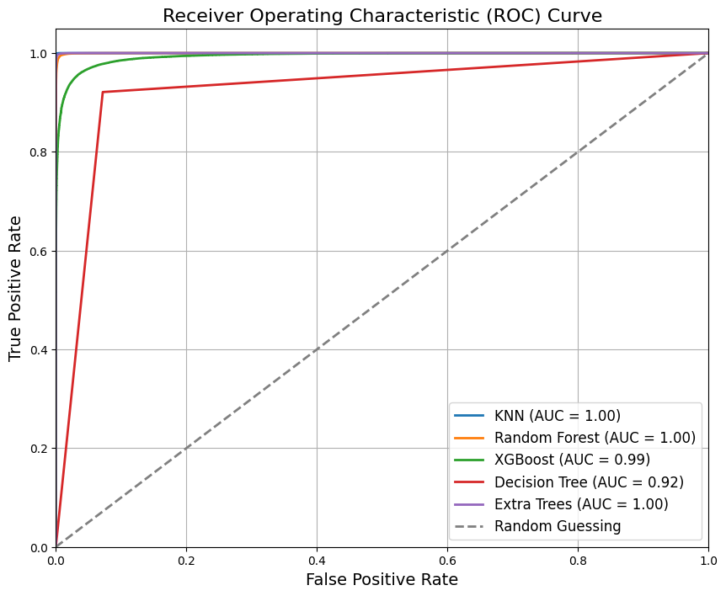

**Figure:** ROC Curve for Machine Learning Results with Filtered Dataset.

**Classification Reports - Filtered Dataset**

**KNN:**

**precision recall f1-score support**

0 1.00 1.00 1.00 77676

1 1.00 1.00 1.00 77614

accuracy 1.00 155290

macro avg 1.00 1.00 1.00 155290

weighted avg 1.00 1.00 1.00 155290

**Random Forest:**

**precision recall f1-score support**

0 0.99 1.00 0.99 77676

1 1.00 0.99 0.99 77614

accuracy 0.99 155290

macro avg 0.99 0.99 0.99 155290

weighted avg 0.99 0.99 0.99 155290

**XGBoost:**

**precision recall f1-score support**

0 0.95 0.97 0.96 77676

1 0.97 0.95 0.96 77614

accuracy 0.96 155290

macro avg 0.96 0.96 0.96 155290

weighted avg 0.96 0.96 0.96 155290

**Decision Tree:**

**precision recall f1-score support**

0 0.92 0.93 0.92 77676

1 0.93 0.92 0.92 77614

accuracy 0.92 155290

macro avg 0.92 0.92 0.92 155290

weighted avg 0.92 0.92 0.92 155290

**Extra Trees:**

**precision recall f1-score support**

0 0.99 1.00 1.00 77676

1 1.00 0.99 1.00 77614

accuracy 1.00 155290

macro avg 1.00 1.00 1.00 155290

weighted avg 1.00 1.00 1.00 155290

**Confusion Metrics - Filtered Dataset**

